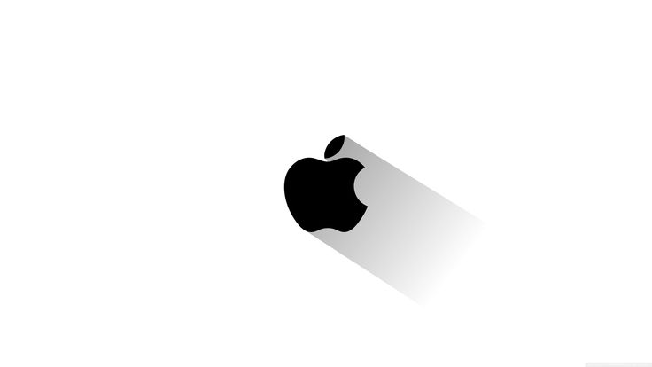 **Apple Inc**

# **Product Dissection for Apple**

**Company Overview:**

Apple Inc. is an American multinational technology company known for its consumer electronics, software, and services. Founded in 1976, the company is best known for products like the iPhone, iPad, and Mac computers. Apple also offers a range of services, including the App Store, Apple Music, and Apple TV+.

Founded in 1976 by Steve Jobs, Steve Wozniak, and Ronald Wayne, Apple Computer was initially focused on personal computers. The company changed its name to Apple Inc. in 2007.

Tim Cook is the current CEO of Apple, apple is a global leader in technology, with a strong presence in various markets.

Apple is the largest technology company by revenue, with $391.04 billion in FY 2024 and operates in the Americas, Europe, Greater China, Japan, and the Rest of Asia-Pacific. 

**Product Dissection and Real-World Problems Solved by Apple:**

Apple Products are categorized in various types, sectors and provides different type of solutions which are mentioned below as follows-

1. **Air pods, Air pods pro and Air pro max**- These are premium true wireless earphones and headphones which has solved real world problem for people who want good quality audio and want premium/luxury feeling while attending business meetings and enjoying their environment.
2. **Mac-book Air, Mac-book Pro-** With industry leading performance and excellent quality with pure luxury mac-books are the first choice for any professionals who want to enhance their business or meet their learning goals. Mac-books solved the real world’s problem by becoming a luxury status as well as a performance leader, because of mac-books mac-OS secured and closed environment capabilities it makes it more reliable and form a thick line of trust.
3. **Mac-Mini, Mac-Studio, Mac-Pro-** For Desktop lovers and people who want powerful desktop with best performance, security and reliability apple introduced mac versions which are available in different customizable options which solves real world problem of having a powerful and compact CPU, due to its small size and various customizable options mac becomes more obvious choice for people or professionals who want to carry their CPU’s to various places for work and entertainment purposes, compared to windows CPU’s these are very less in weight and easily portable.
4. **I-pad, I-pad mini, I-pad Air and I-pad Pro-** I-pad are the powerful tablets which comes in both types which is either a A-series chipset or M-Series chipset with I-pad OS specially curated for I-pad, they solved various types of real world problems for professionals and students who are graphic designers, learners, painters, architects, civil engineers, gamers, IT professionals, teachers, video editors, music producers, DJ players and many more. Not only I-pad is light weight but also these devices are very smooth to operate and often provide security updates and closed ecosystem to avoid data breaching and to protect users data and personal Identity secure because of which they preferred more often as their costs are also under 1 lakh rupees, making them affordable and better than its competitors.
5. **Apple Series and Ultra Watch-** Apple provides excellent fitness and luxury product which is there watch which provides seem less data regarding ECG, heart rate, step counts, SP02, and many sports activity tracker modes, these watches are not only rigid and stylish but also super water resistant, company claiming that these watches can handle water pressure up to 50-100 ft depth of water with 100% accurate results for all the trackers and sports mode. These watches have helped fitness enthusiasts and professional sports persons to track down their performance with accurate results in real world solving many problems such as to store and keep track of performance data for long period of time.
6. **Apple I-phone-** Apple I-phone are powerful mobile phones which comes with powerful A bionic chipset which are customized by apple itself making these phones secure and provides closed ecosystem which are protected from malwares and virus, these phones are hard to hack thus makes them reliable for customers who are seeking to use it for business and professional purposes, In real world many problems have been solved by I-phones like lag free UI, best performance, closed and secure ecosystem, luxury and premium feel, connectivity within apple ecosystem across all other products making it easy to use.

## **Problem 1: Open-Source Ecosystem and UI with Lag Issues**

## **Solution-** Apple provides closed ecosystem which solves the problem of open- source ecosystem and keeps apple products secure from hacking, malware and virus attacks, talking about the lag issues with A bionic chipset in I-phones and M series chipset in mac-books makes the devices powerful and lag free with best UI having no or less bloat-wares.

## **Problem 2: Performance**

## **Solution-** Many non-apple products lack performance due to open-source ecosystem and less powerful processors or chipsets, in case of Apple it comes with closed ecosystem and custom self-made industry leading chipsets and processors making them top in terms of performance, battery backup and durable in market.

## **Problem 3: Reliability and long lasting**

## **Solution-** Due to secured network and better chipsets/ processors apple products becomes more reliable and long lasting compared to its competitors, customers often say that the apple product which they are using from past 10 years also works fine today which gives proof that these devices are very long lasting, secure and reliable.

## **Problem 4: Data Security and Personal Identity**

## **Solution-** To solve this problem apple provide closed ecosystem which means the operating system and chipset which they are using are used by their products only making it separate from outer world and thus making them secured devices along all types of products, taking about Personal Identity, apple makes anonymous and provides encryption feature to its users within ecosystem to avoid Identity theft.

**Top Features of Apple Inc-**

1. Provides closed ecosystem and secure network among all of its devices and products.
2. Apple TV and Apple TV+ is a personalized apple OTT platform for artists to showcases amazing content and also users get to see quality and limited content which is only available on this platform, making it premium.
3. Apple Home pods which are amazing AI personalized assistants which helps customers with amazing assistant facilities like smart home controls, music control, voice assisted news and alarm, seem-less connectivity across all apple products.
4. Apple Music is a personalized music app feature only available to apple customers making it premium and secured.
5. Safari web browser is a powerful web browser which runs on apple servers making it most secured web browsers.
6. Final Cut pro is a video editing device which is only available to apple users on certain products making it among one of the most powerful editing app which is used by most professionals.
7. GarageBand and Logic Pro are the music production apps specially curated for apple devices and provides seem-less performance for producing, editing, mixing and mastering music and recommended by most musicians in the market.
8. I-cloud is a cloud service only provided to apple users for backing up data for future data transfer purposes and also for business purposes.
9. FaceTime app created by apple to provide quality video calls for personal and professional usage, the best part of this app that it provides encrypted video calling service.
10. I-Movie is apple customized app which provides movie editing feature and helps you to make industry grade movie.
11. Apple Pay is an app created by apple Inc to provide its users payment facility capabilities or Payment through NFC.

**Schema for Apple Inc-**

1. **Database schema** – **A structured layout of tables and relationships for storing information about Apple Inc (e.g., products, employees, stores, sales, etc.).**

**Products**

| **Field** | **Data Type** | **Description** |
| --- | --- | --- |
| product_id | INT (PK) | Unique ID for the product |
| name | VARCHAR | Name of the product |
| category | VARCHAR | e.g., iPhone, MacBook, iPad |
| price | DECIMAL | Price of the product |
| release_date | DATE | Release date |
| stock_quantity | INT | Inventory count |
| discontinued | BOOLEAN | Whether the product is still active |

**Customers**

| **Field** | **Data Type** | **Description** |
| --- | --- | --- |
| customer_id | INT (PK) | Unique ID for each customer |
| name | VARCHAR | Full name |
| email | VARCHAR (UNIQUE) | Email address |
| phone | VARCHAR | Contact number |
| address | TEXT | Shipping address |
| registered_on | DATE | Date of account creation |

**Orders**

| **Field** | **Data Type** | **Description** |
| --- | --- | --- |
| order_id | INT (PK) | Unique order ID |
| customer_id | INT (FK) | Linked to Customers |
| order_date | DATE | Date of order |
| total_amount | DECIMAL | Total cost of the order |
| payment_status | VARCHAR | e.g., Paid, Pending, Refunded |

**Order_Items**

| **Field** | **Data Type** | **Description** |
| --- | --- | --- |
| order_item_id | INT (PK) | Unique ID for item in an order |
| order_id | INT (FK) | Linked to Orders |
| product_id | INT (FK) | Linked to Products |
| quantity | INT | Quantity ordered |
| price_each | DECIMAL | Price at time of purchase |

**Employees**

| **Field** | **Data Type** | **Description** |
| --- | --- | --- |
| employee_id | INT (PK) | Unique employee ID |
| name | VARCHAR | Employee name |
| position | VARCHAR | Job title |
| department | VARCHAR | e.g., R&D, Retail, Support |
| hire_date | DATE | Employment start date |
| store_id | INT (FK) | If applicable, linked to store |

**Stores**

| **Field** | **Data Type** | **Description** |
| --- | --- | --- |
| store_id | INT (PK) | Unique store ID |
| name | VARCHAR | Name of the store |
| location | VARCHAR | City or mall name |
| region | VARCHAR | Geographic region (e.g., US, Europe) |

**Shipments**

| **Field** | **Data Type** | **Description** |
| --- | --- | --- |
| shipment_id | INT (PK) | Unique shipment ID |
| order_id | INT (FK) | Linked to Orders |
| shipped_date | DATE | Date shipped |
| delivery_date | DATE | Date delivered (or expected) |
| status | VARCHAR | e.g., In Transit, Delivered, Delayed |

**🔁 Relationships**

* A Customer can have many Orders
* An Order can contain many Order_Items, and each item is a Product
* Employees can be assigned to Stores
* Shipments are linked to Orders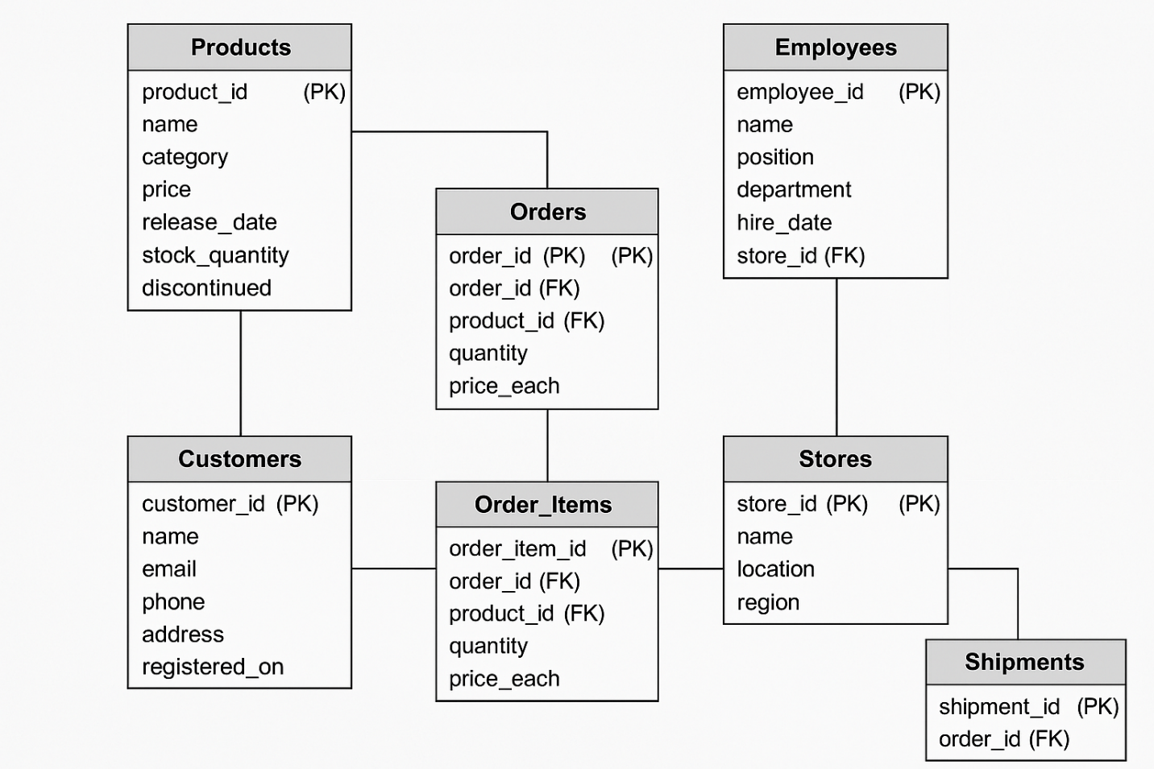

1. **Organizational schema** – **A breakdown of Apple Inc’s corporate structure (e.g., CEO, departments like hardware, software, services, etc.).**

**Departments**

* ID, Name, Location
* Examples: Hardware Engineering, Software Engineering, Retail, Marketing, Services

**Executives**

* ID, Name, Title, Department_ID (FK)
* Examples: CEO, CFO, COO, SVP of Hardware, SVP of Software

**Teams**

* ID, Name, Department_ID (FK), Lead_Employee_ID (FK)

**Employees**

* ID, Name, Title, Department_ID (FK), Team_ID (FK), Manager_ID (FK – self join)

**Projects**

* ID, Name, Team_ID (FK), Start_Date, End_Date, Status

**Products**

* ID, Name, Managed_By_Team_ID (FK), Category (e.g., iPhone, Mac, Services)

**🧩 Relationships Overview**

* Departments have multiple Executives and Teams.
* Each Team belongs to a Department and is led by an Employee.
* Employees work in Teams and Departments and can report to a Manager (self join).
* Projects are managed by Teams.
* Products are overseen by Teams.

1. **Business model schema** – **A high-level overview of how Apple operates, including revenue streams, value propositions, customer segments, etc.**

**Customer_Segments**

* ID, Segment_Name, Description
* e.g., Consumers, Enterprises, Education, Developers

**Value_Propositions**

* ID, Proposition, Description
* e.g., Seamless integration of hardware/software, Premium design, Privacy

**Channels**

* ID, Channel_Name, Type (Online/Offline), Description
* e.g., Apple Store, Website, App Store, Authorized Resellers

**Customer_Relationships**

* ID, Type, Description
* e.g., Personalized support, Self-service, Community forums

**Revenue_Streams**

* ID, Stream_Name, Type (Product/Service), Amount, Frequency
* e.g., iPhone sales, App Store commission, iCloud subscription

**Key_Activities**

* ID, Activity_Name, Description
* e.g., Product Design, R&D, Software Development

**Key_Resources**

* ID, Resource_Name, Type (Physical, Intellectual, Human)
* e.g., Brand, Patents, Hardware facilities, OS

**Key_Partnerships**

* ID, Partner_Name, Type (Supplier/Strategic), Industry
* e.g., Foxconn, TSMC, Developers

**Cost_Structure**

* ID, Cost_Type, Amount, Description
* e.g., Manufacturing, Marketing, R&D

**🔁 Relationships Overview**

* Each **Value Proposition** targets one or more **Customer Segments**
* **Channels** deliver **Value Propositions** to **Customer Segments**
* **Customer Relationships** support **Customer Segments**
* **Revenue Streams** are linked to **Customer Segments** and **Value Propositions**
* **Key Activities** use **Key Resources**
* **Key Partnerships** support **Key Activities**
* **Cost Structure** is driven by **Activities**, **Resources**, and **Partnerships**

1. **Website schema (structured data)** – **Schema.org markup for Apple’s website to improve SEO (e.g., Organization, Product, etc.).**

**Organization**

* @type: Organization
* name, url, logo, founder, foundingDate, sameAs (social links)

**WebSite**

* @type: WebSite
* name, url, potentialAction (e.g., SearchAction), publisher (Organization)

**WebPage**

* @type: WebPage
* name, url, description, breadcrumb, mainEntity (e.g., Product)

**Product**

* @type: Product
* name, image, description, brand, sku, offers (linked to Offer)

**Offer**

* @type: Offer
* price, priceCurrency, availability, itemCondition, seller

**BreadcrumbList**

* @type: BreadcrumbList
* List of ListItem with position and item (name + URL)

**SearchAction**

* @type: SearchAction
* target, query-input

**🔁 Relationships Overview**

* WebSite is published by an Organization
* WebPage belongs to a WebSite
* WebPage may contain a Product
* Product has an Offer
* WebPage includes a BreadcrumbList
* WebSite can define a SearchAction

1. **Financial data schema** – **Layout of financial data like income statement, balance sheet, and cash flow.**

**Accounts**

* account_id, name, type (Revenue, Expense, Asset, Liability, Equity), subtype (optional)

**Periods**

* period_id, start_date, end_date, fiscal_year, quarter, type (Annual/Quarterly)

**Transactions**

* transaction_id, account_id (FK), period_id (FK), amount, currency, note

**Financial_Statements**

* statement_id, type (Income, Balance Sheet, Cash Flow), period_id (FK)

**Statement_Lines**

* line_id, statement_id (FK), account_id (FK), amount, line_order, label

**Currencies**

* currency_code, symbol, name, exchange_rate_to_usd

**Auditors**

* auditor_id, name, firm, audit_year, report_type (Clean, Qualified, etc.)

**🔁 Relationships Overview**

* Transactions link Accounts with Periods
* Financial_Statements are generated per Period
* Each Financial_Statement includes multiple Statement_Lines (each linked to an Account)
* Currencies may be referenced in Transactions
* Auditors are linked to a Financial_Statement per fiscal year

**ER Diagrams for various schema of Apple Inc**

Let’s create different Entity Relation diagrams for various types of schema for Apple Inc

**Database Schema ER**

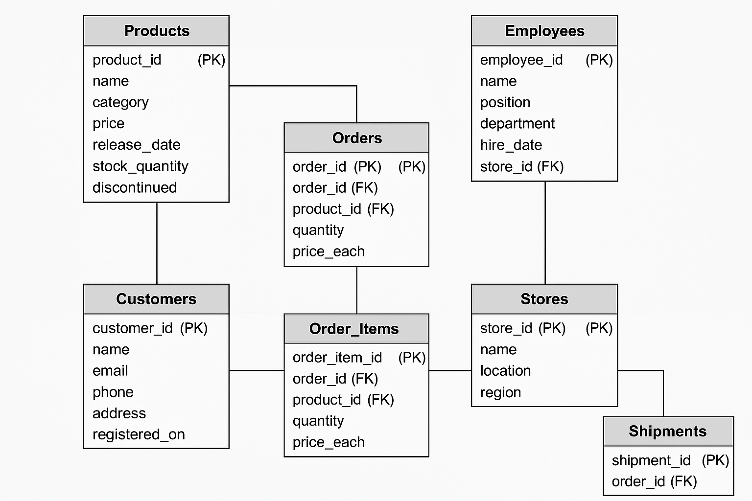

**Organizational Schema ER**

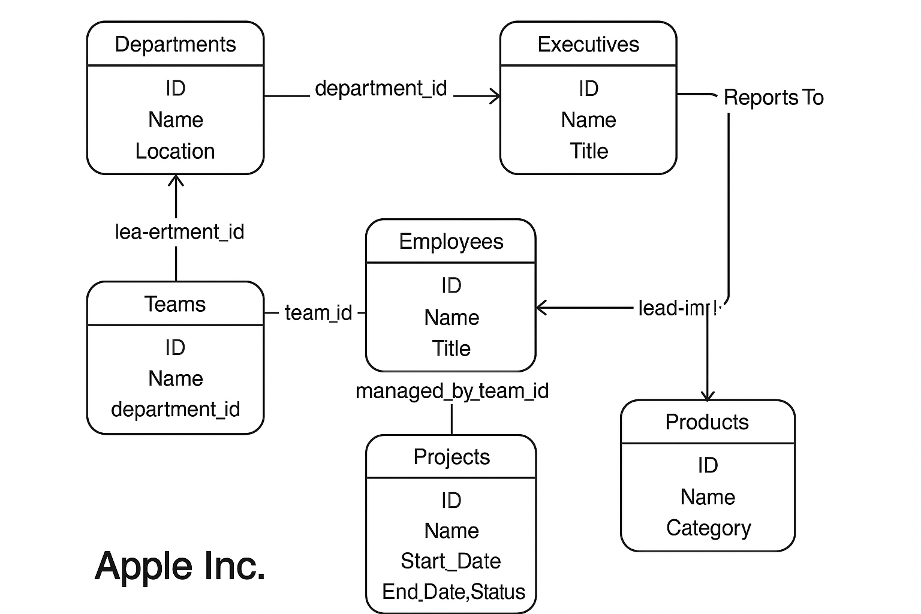

**Business Model Schema ER**

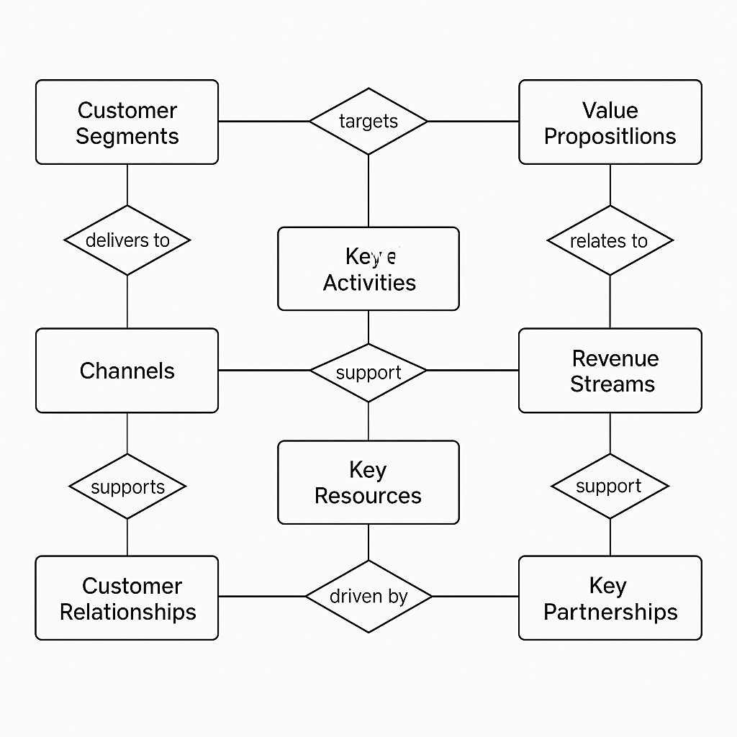

**Website Data (Structured Schema) ER**

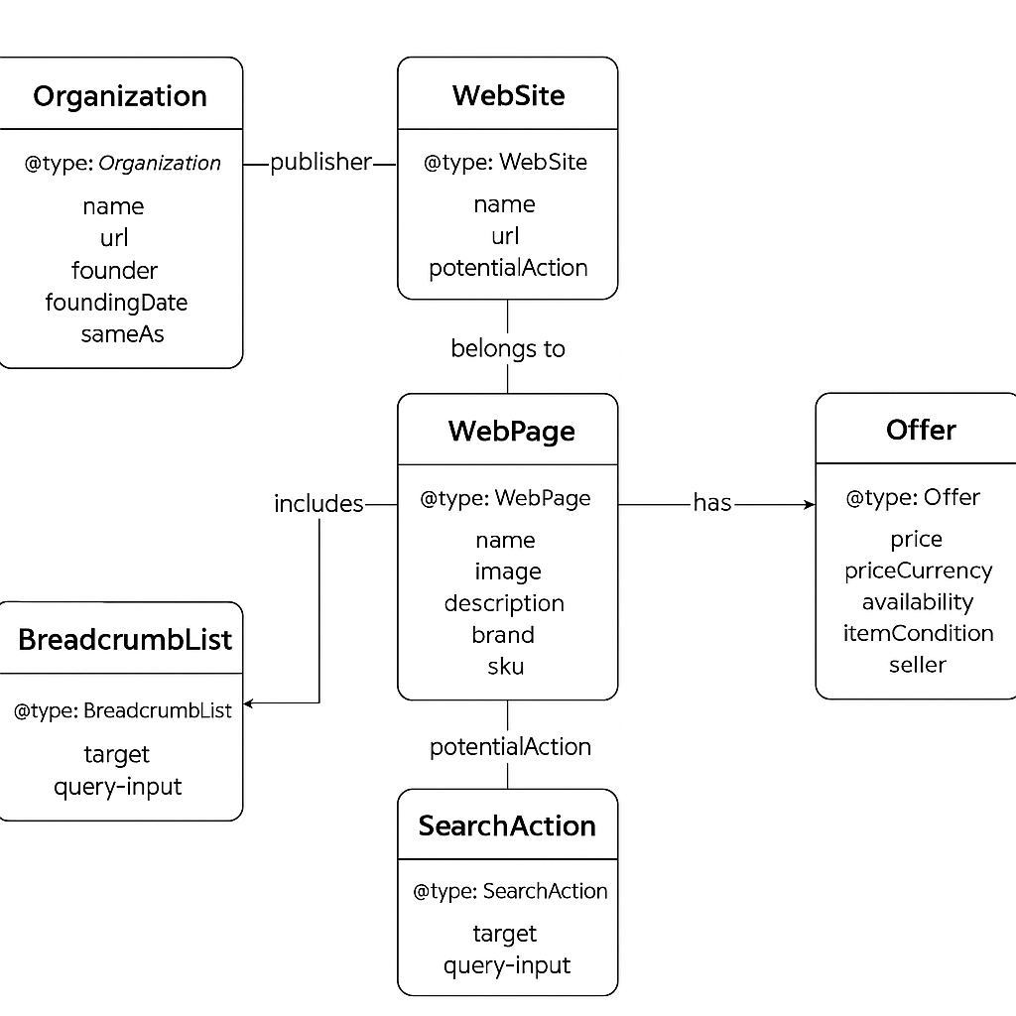

**Financial Schema ER**

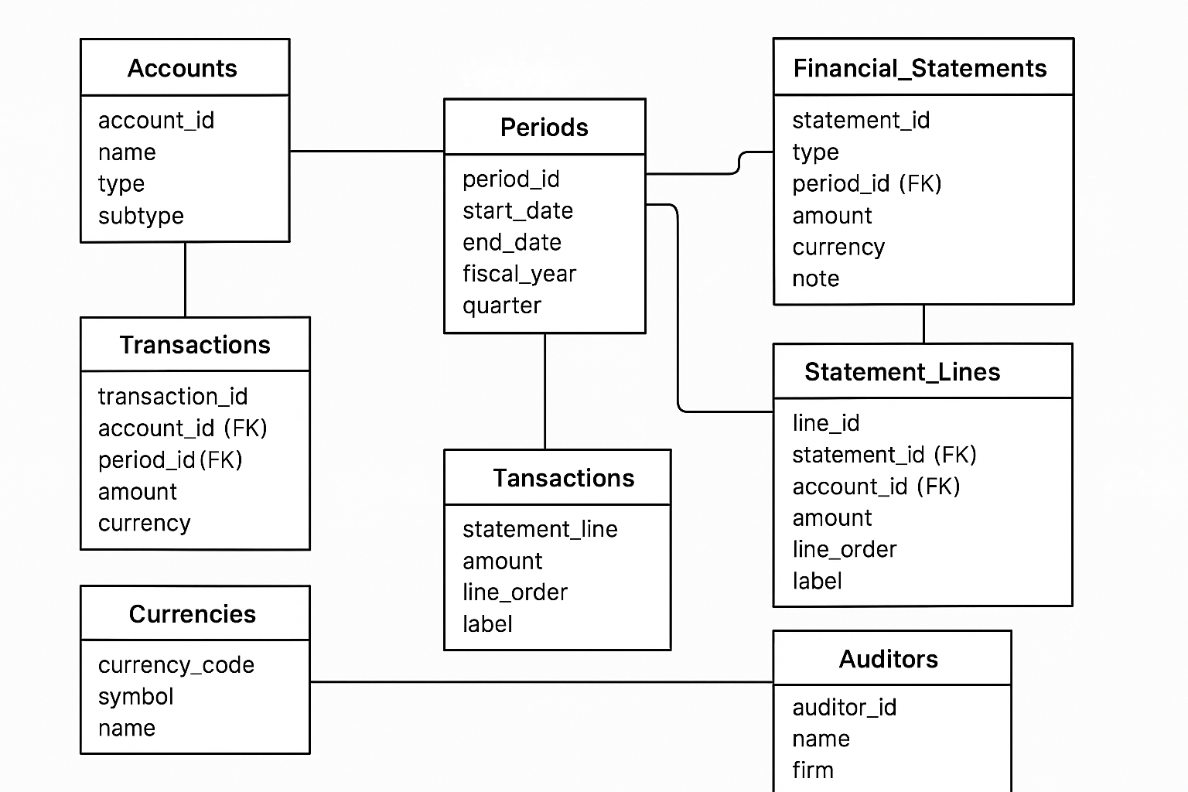

**Conclusion-**

As conclusion we can say that Apple Inc is an organization which not only sells product but also sells a sense of owning a luxury and premium products ultimately making it different from others, because of its closed ecosystem and self-made chipsets and operating system makes it even more reliable, safe and durable to use, Apple products are often long lasting and perform best performance making them industry leaders in the market, not only they excellence with their product quality but also provide amazing after sales services to its users.